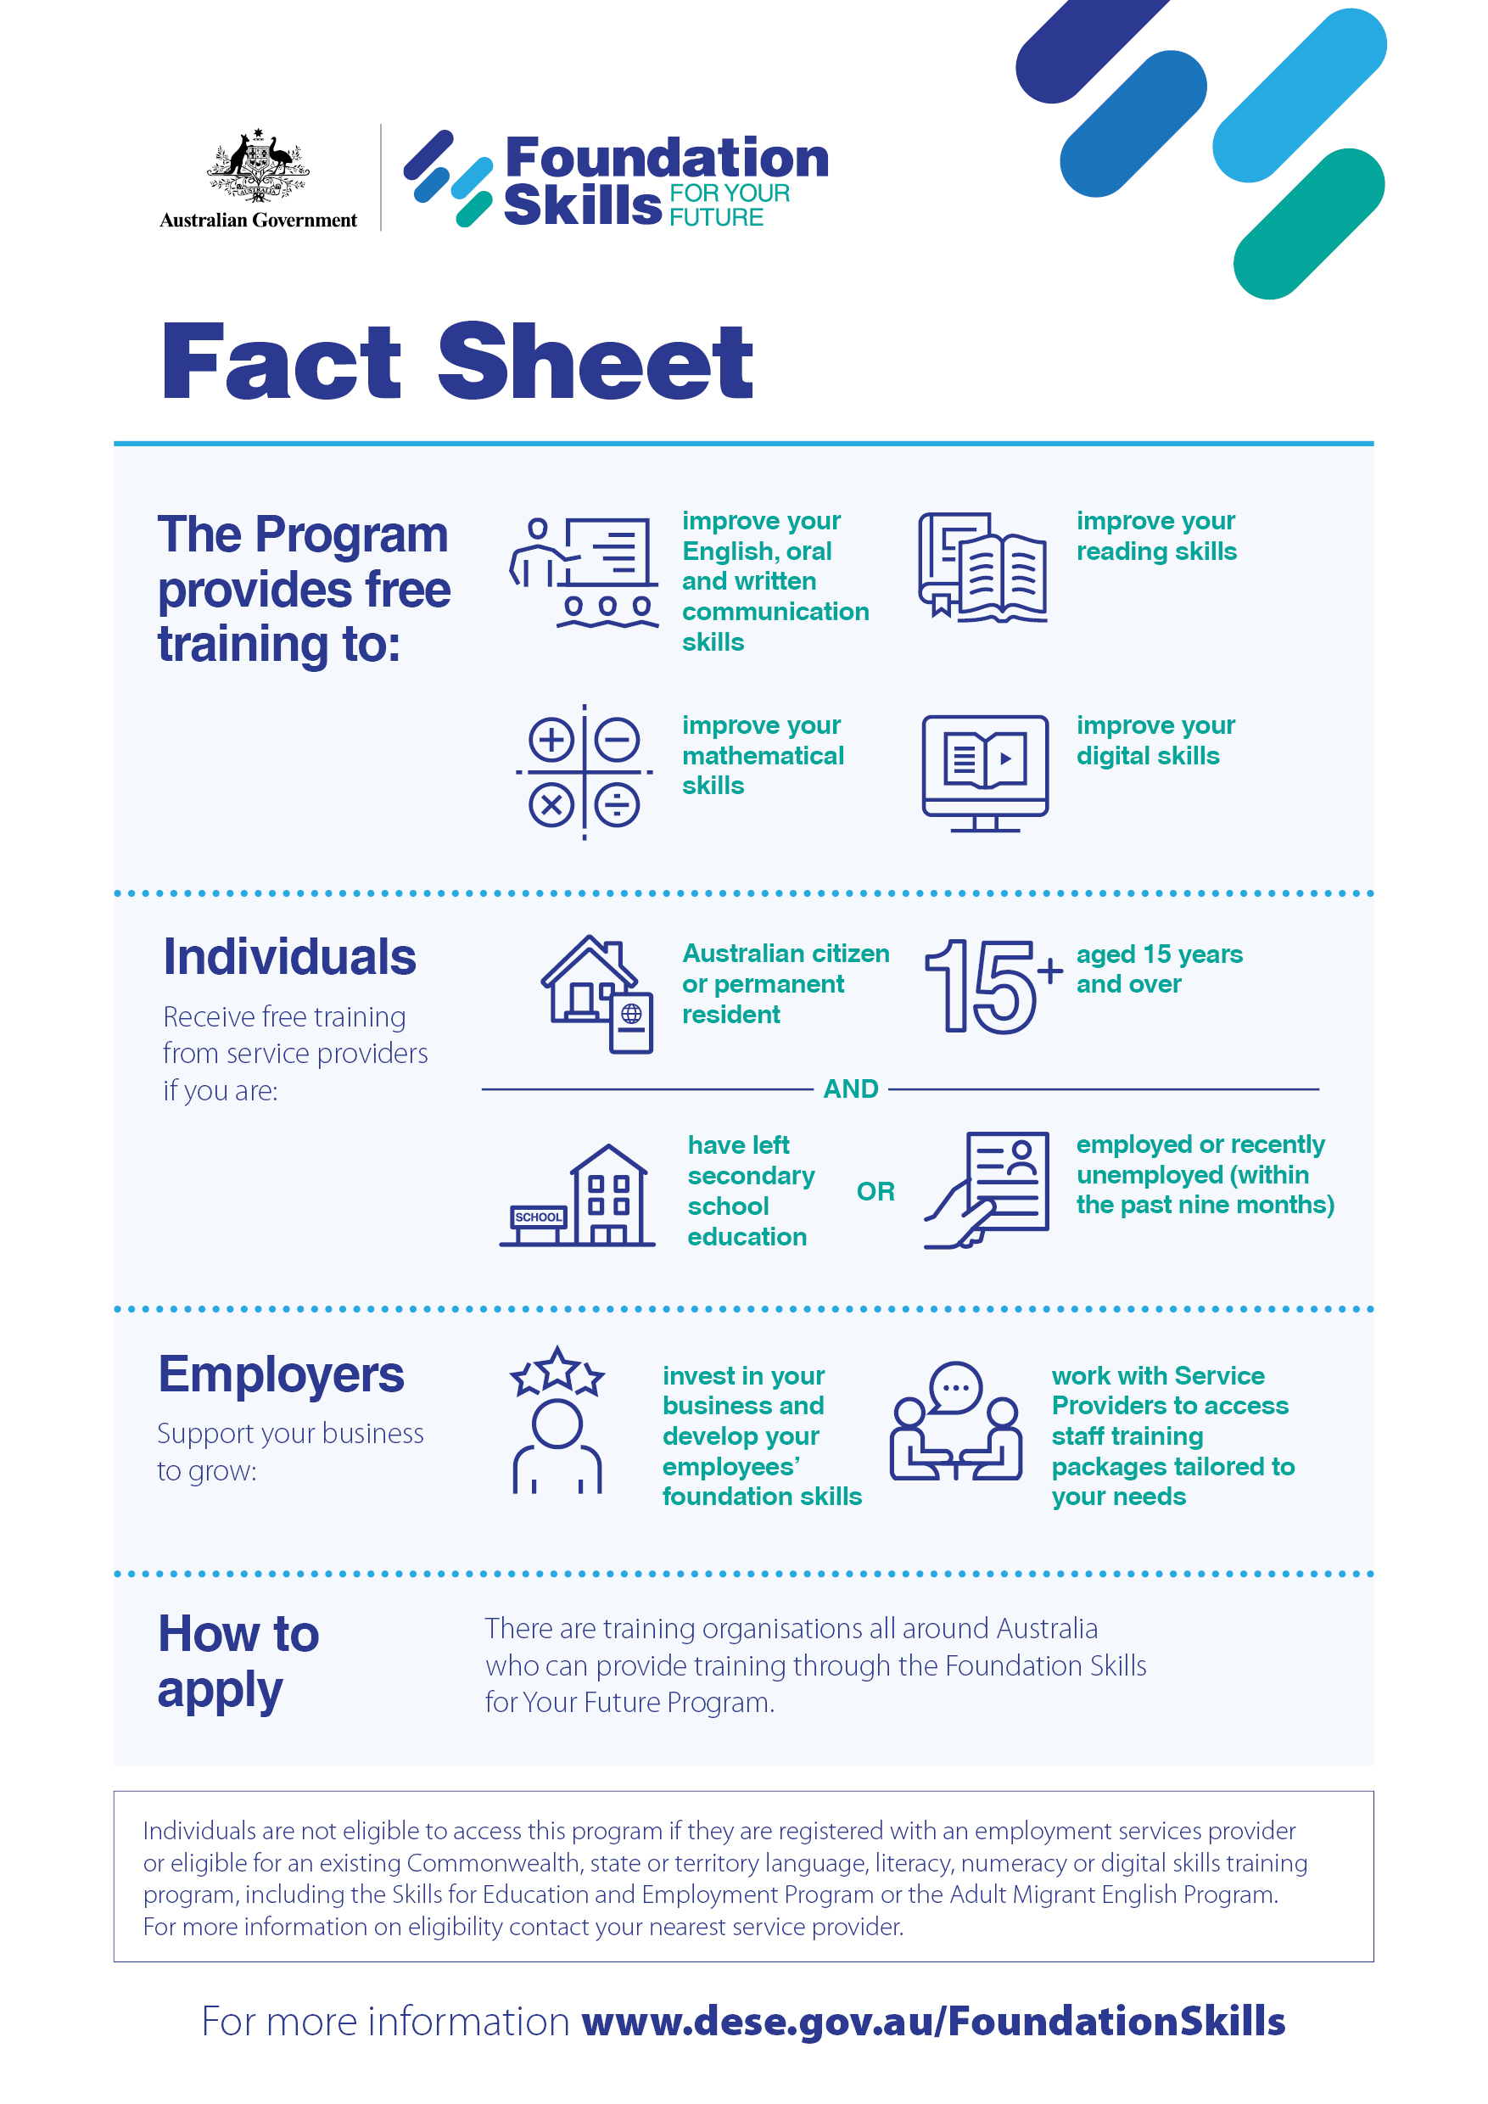

Fact sheet

This program provides free training to:
- improve your English, oral and written communication skills
- improve your reading skills
- improve your mathematical skills
- improve your digital skills

Individuals
Receive free training from service providers if you are:
- Australian citizen or permanent resident
- aged 15 years and over
And:
- have left secondary school education; or
- employed or recently unemployed (within the past nine months)

Employers
Support your business to grow:
- invest in your business and develop your employees’ foundation skills
- work with Service Providers to access staff training packages tailored to your needs

How to apply
There are training organisations all around Australia who can provide training through the Foundation Skills for Your Future Program.
Individuals are not eligible to access this program if they are registered with an employment services provider or eligible for an existing Commonwealth, state or territory language, literacy, numeracy or digital skills training program, including the Skills for Education and Employment Program or the Adult Migrant English Program.
For more information on eligibility contact your nearest service provider.
For more information www.dese.gov.au/FoundationSkills

